Database
Mysql

Open aws console create databasestandardMysqlfree tier
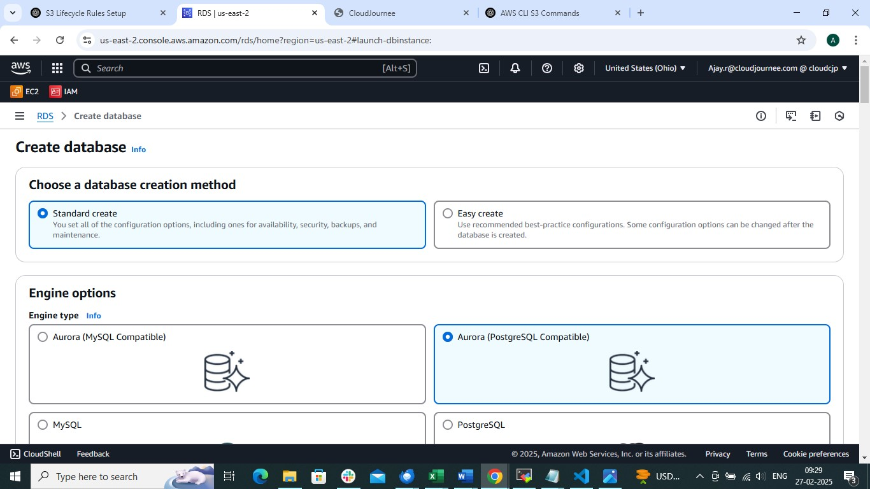
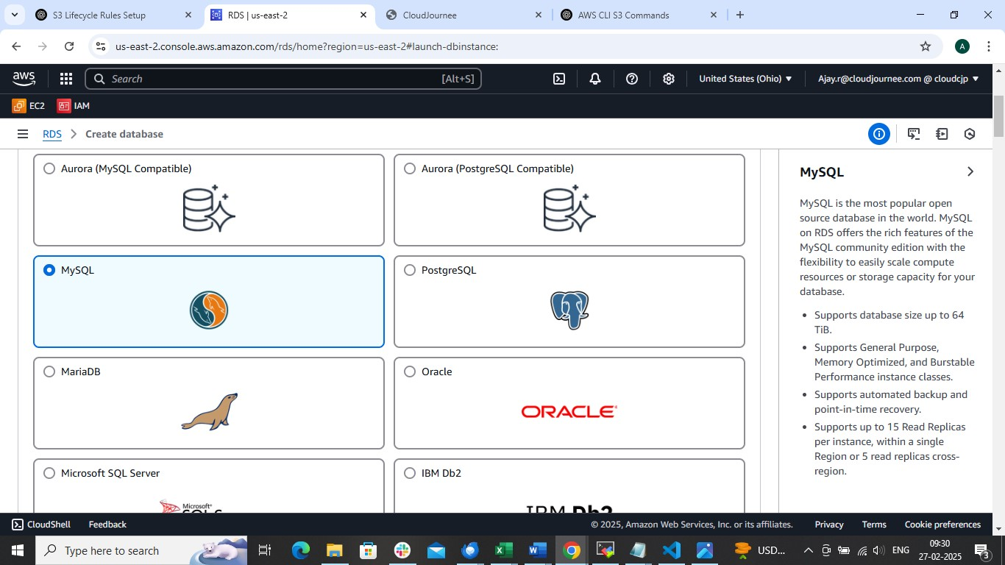

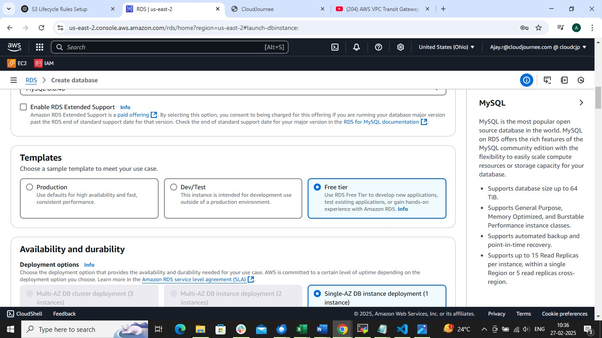

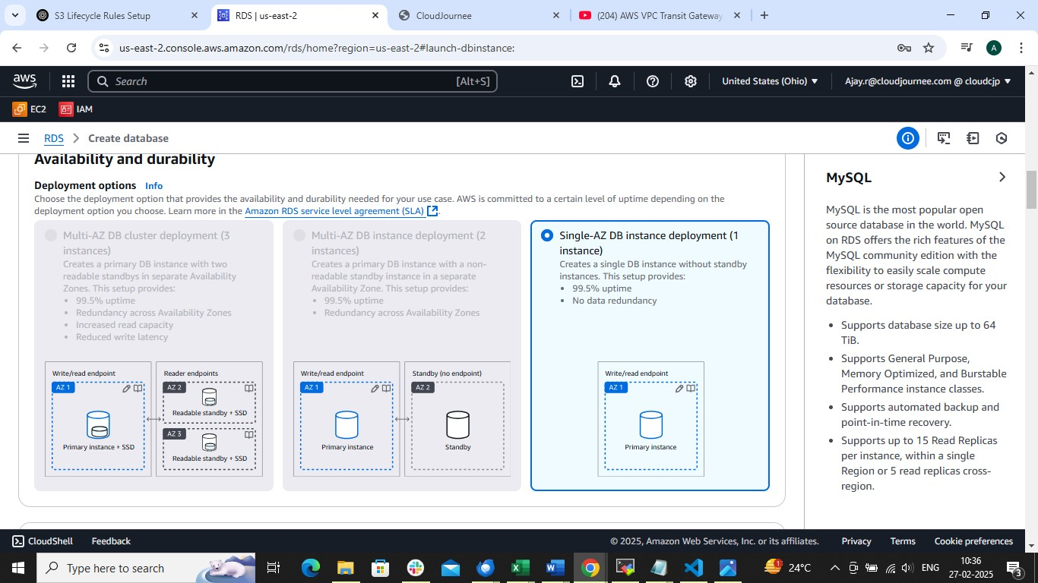

Set master username and password Important to remember

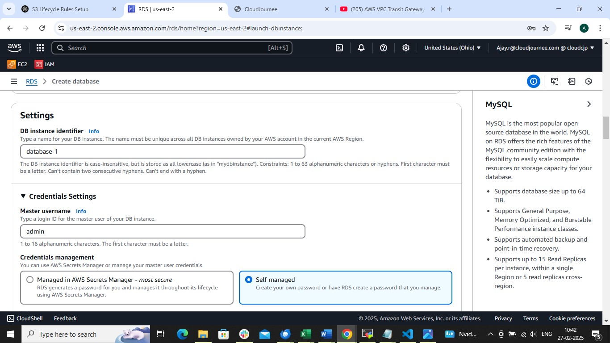

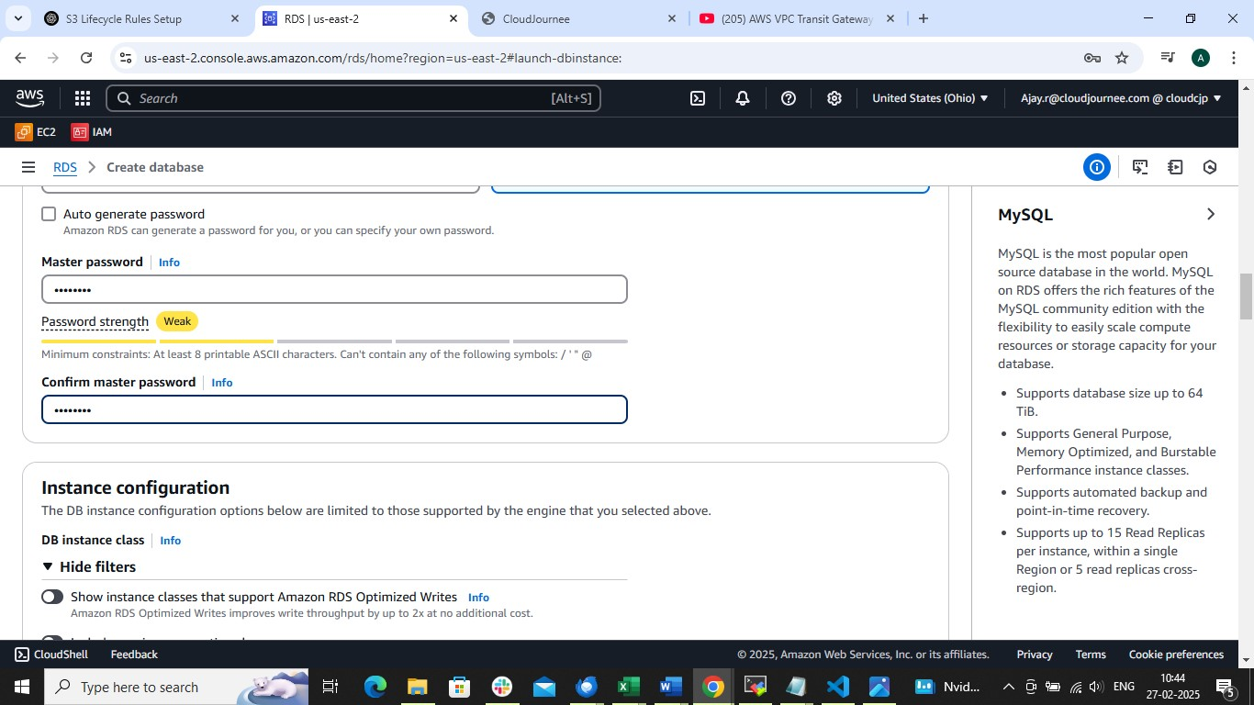

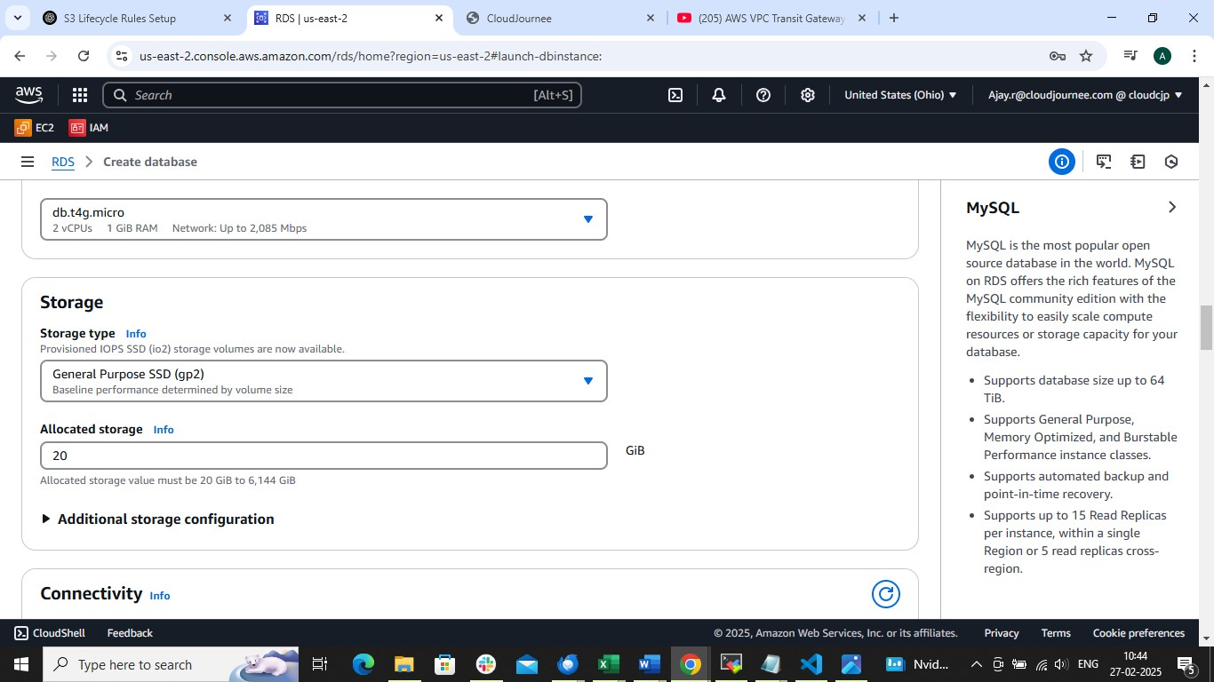

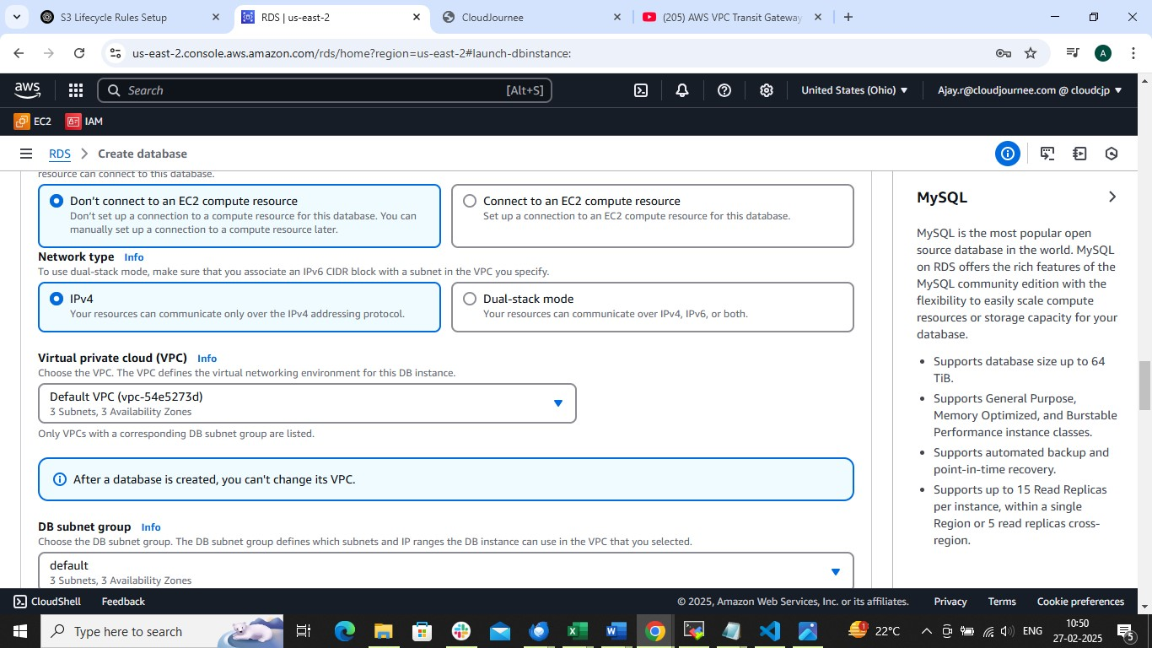

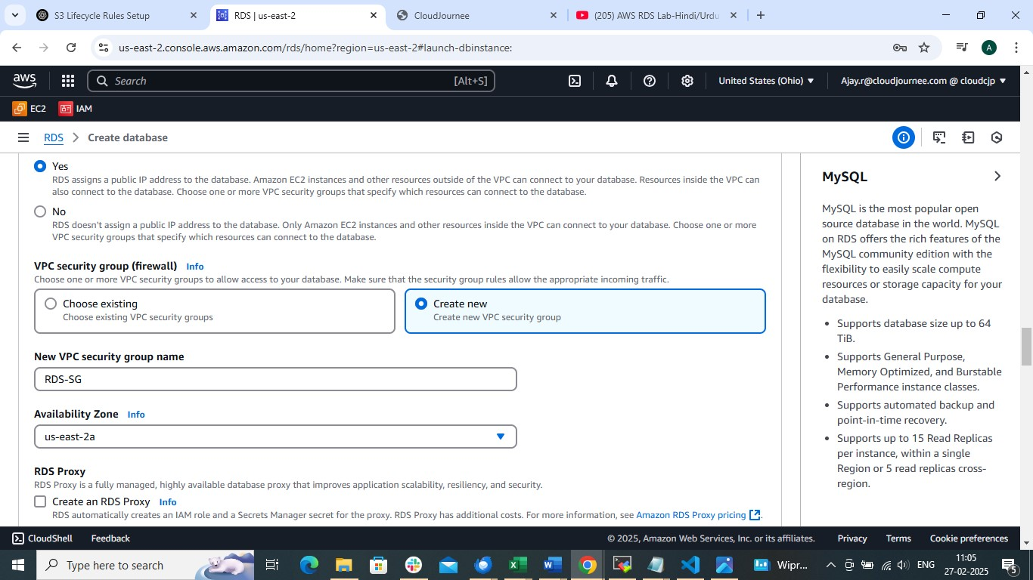

Create new Security group and use the same while launching instance
After creating database remember to add ssh rule
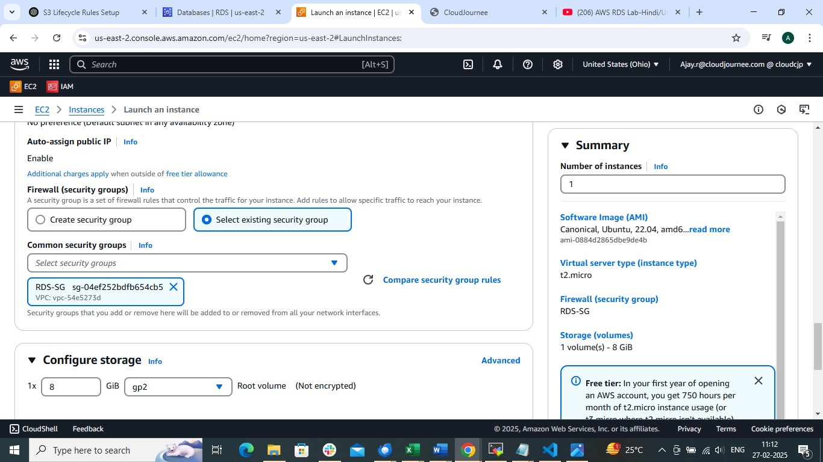

Click on create database and launch instance using same Security group
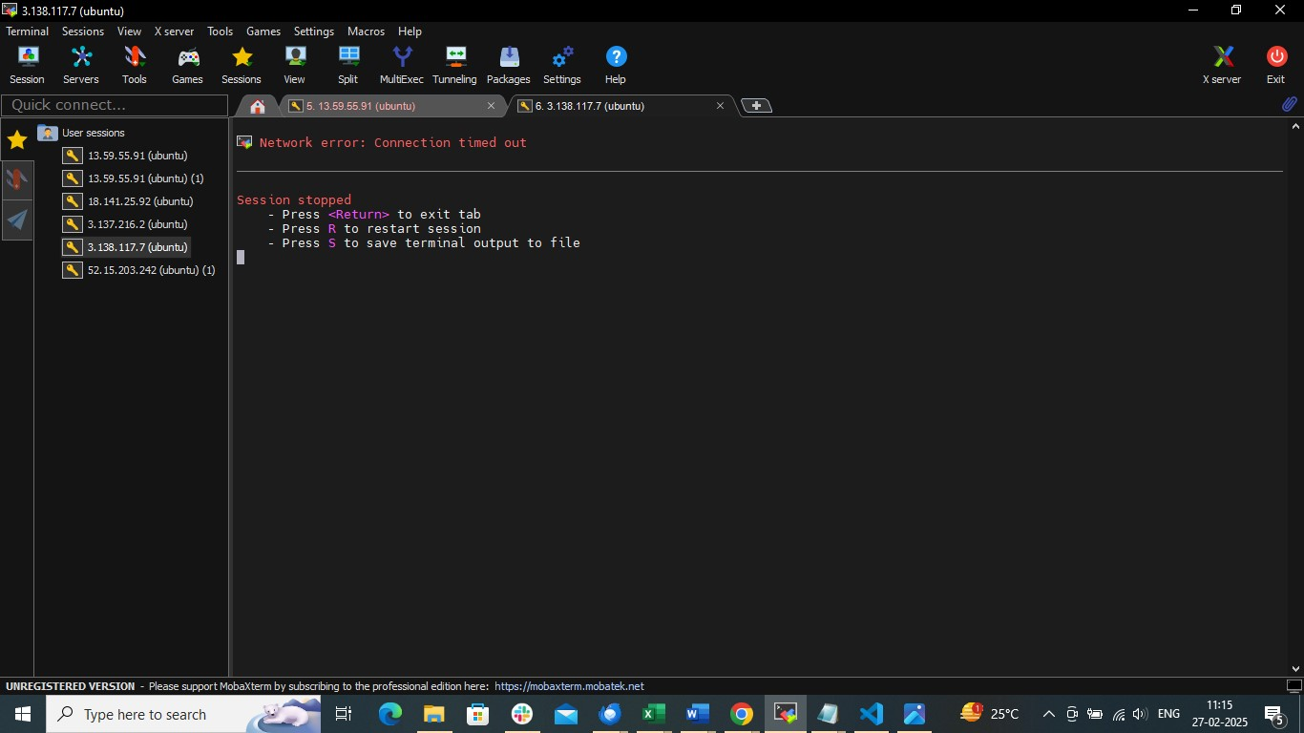
Because we didn’t allowed ssh rule
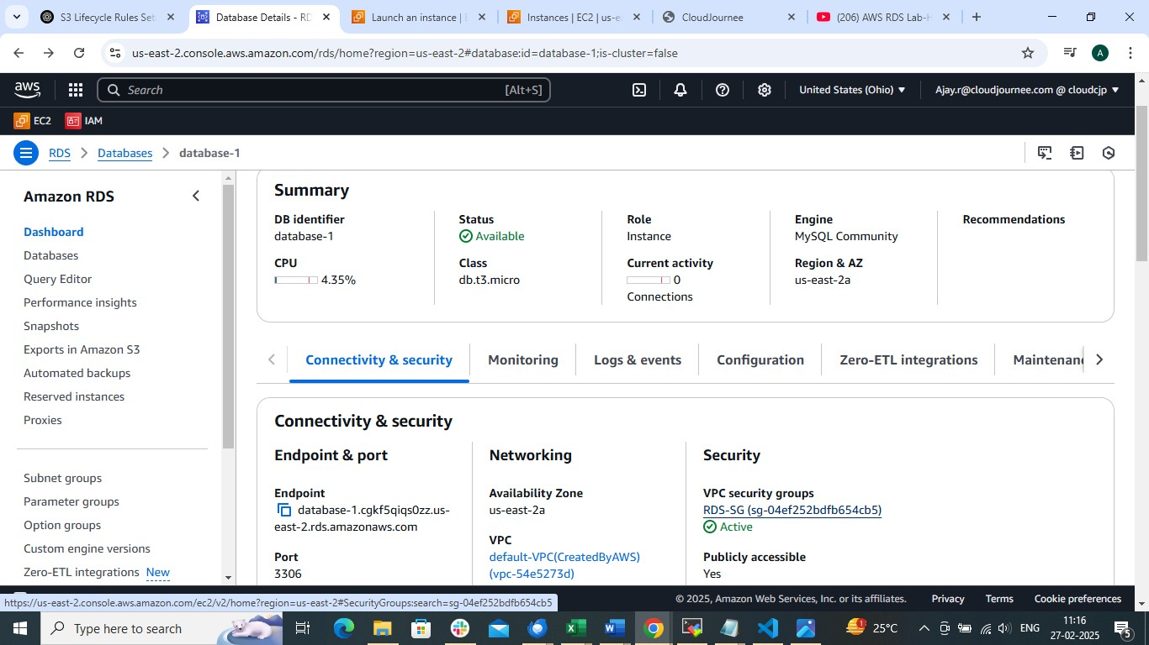
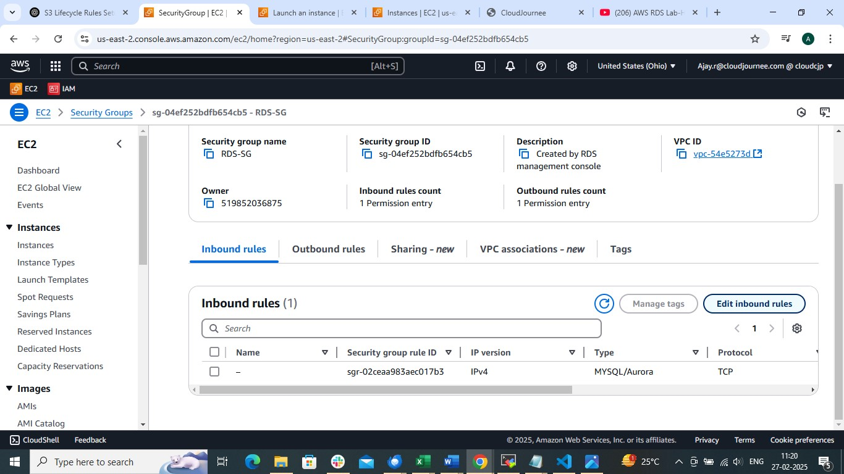

Now we need to install apache2 to host and configure php application
1. apt install apache2 -y
2. cd /var/www/html/
3. rm -rf index.html
4.
Now copy the index.php file to this location

To install mysql follow this steps
1. sudo apt install mysql-server -y
2. sudo systemctl start mysql.service
3. add-apt-repository -y ppa:ondrej/php
4. apt-get install mysql-client -y
5. sudo apt install php5.6 php5.6-mysqli -y ( this will php to run php application (depending upon application we need to install it )
6.
mysql -h end-point-of-database -u admin -p
enter password
that’s it
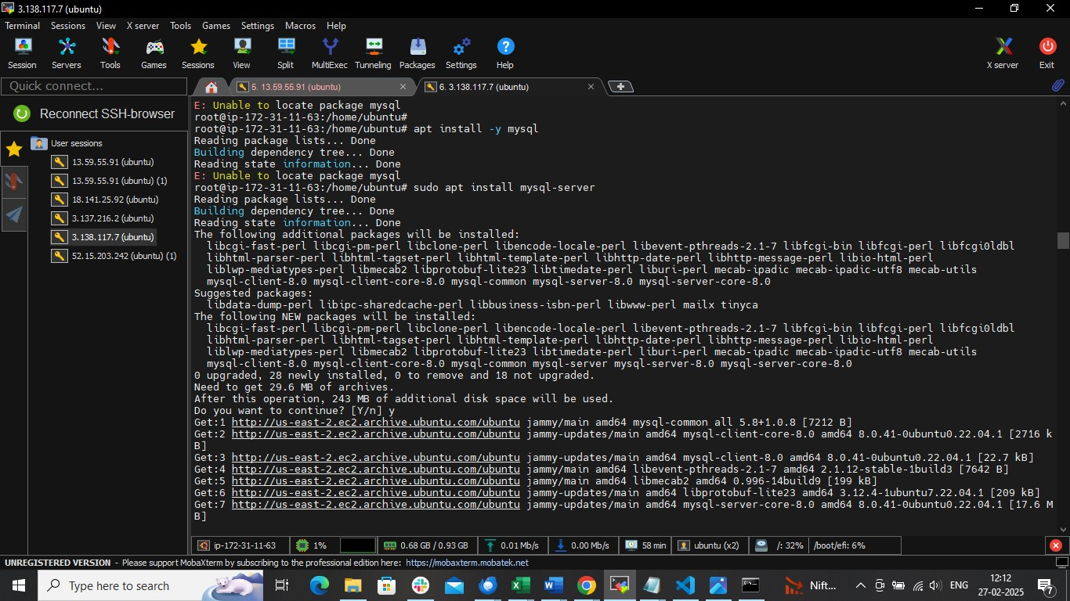

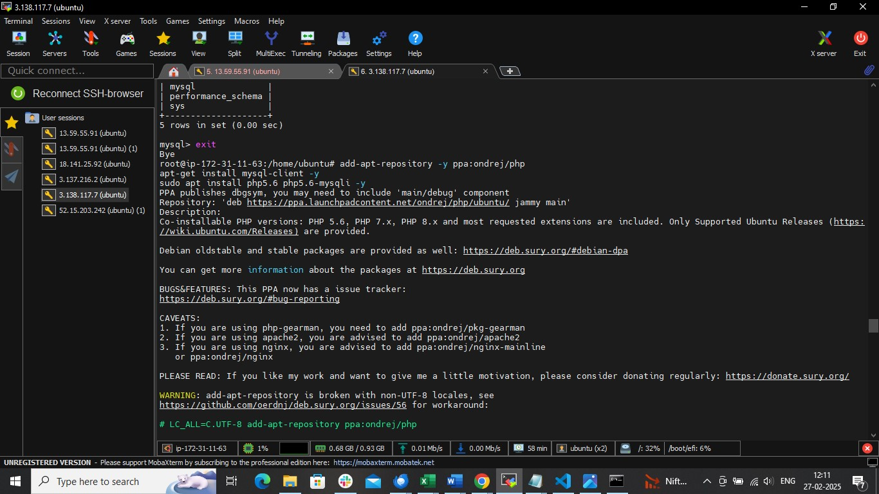

Run : show databases;
Use db1;

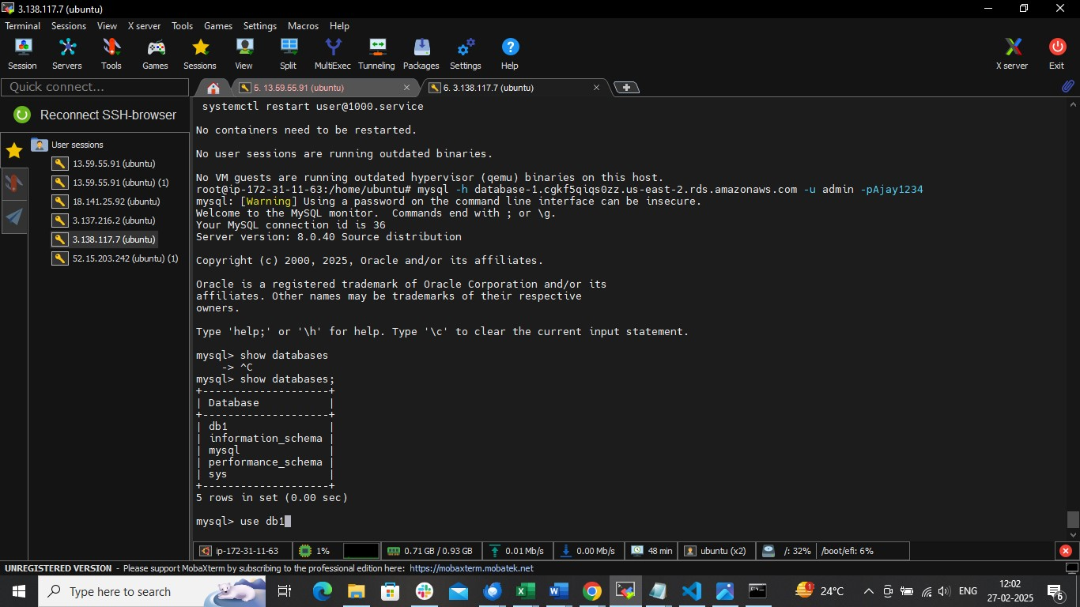

Take public ip access on browser

After that be inside db1 database and command
CREATA TABLE DATA (firstname VARCHAR (20), email VARCHAR (20));
now go to the browser add first name and email
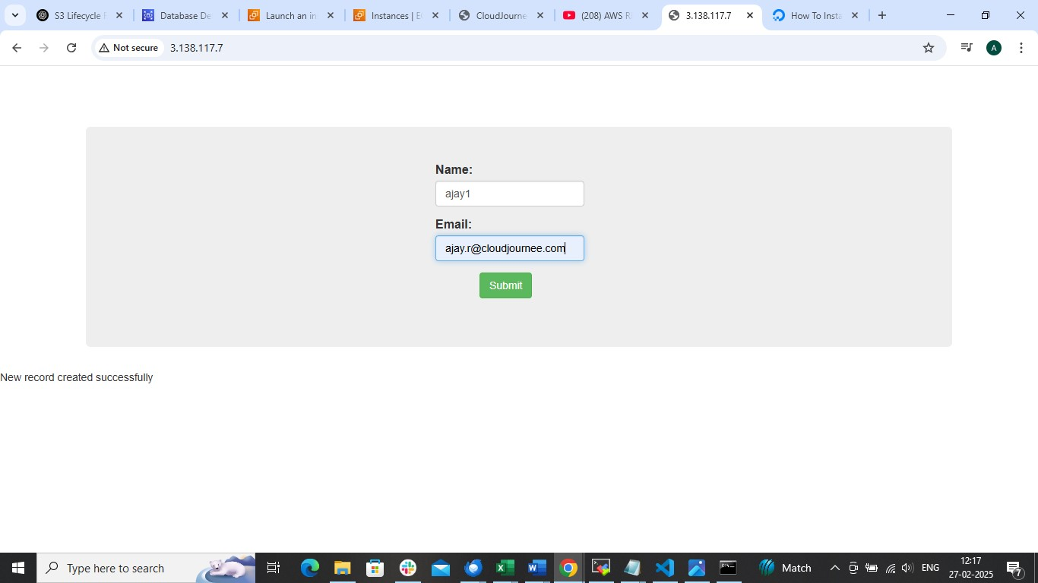

After that run this command
Select * from DATA;
It will show the details of data table
